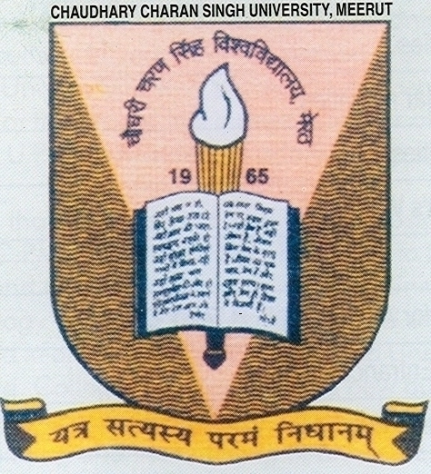

**DIRECT ADMISSION TO FIRST YEAR OF B.TECH (EC, EI, CS, IT, AG, ME, CH), MCA, MBA, MBA-IB & SECOND YEAR (Lateral Entry) TO B.TECH (EC, EI, CS, IT, AG, ME, CH) & MCA, AGAINST VACANT SEATSUPTU COUNSELLING 2015 FOR SESSION 2015-16.**

**B.TECH.:-** Students who could not deposit Rs. 15000/- for seat confirmation will be given priority one. Students who have cleared UPSEE Exam-2015 and could not join the counseling will be given admission under Priority II and other students who have passed intermediate (PCM) and obtained 60% (Gen/OBC) and 55% SC/ST will be given admission in B.Tech as per merit. Candidates having 60% marks FOR Gen/OBC and 55% for SC/ST in Diploma/B.Sc. may also apply for admission through Lateral Entry in IInd Year.

**MCA**. Who have cleared their UG (with Math in 10+2) and obtained 60% marks Gen/OBC and 55% marks SC/ST will be given admission in Ist year and who have cleared B.Sc.(CS/IT) & BCA and obtained 60% marks Gen/OBC and 55% marks SC/ST will be given admission in 2nd year.

**MBA & MBA (IB):-** Candidates who have cleared their graduation and obtained 60% Gen/OBC and 55% SC/ST will be given admission in MBA & MBA (IB).

Desirous candidates have to register themselves at the institute along with a DD of **Rs. 1000/-** (for Gen/OBC) and **Rs. 600/-** (for SC/ST) in favour of **"F. O., CCS University, Meerut"** **latest by 11 Aug. 2015.**

For vacant seats. The admission will be strictly as per merit to be declared on 12 Aug. 2015 at 5:00 PM on the institute website WWW.CCSUSCRIET.ORG. Students having agriculture educational background will be given admission in Agri. Branch only. Branch will be allotted as per merit. Counseling will be done on 13th & 14th Aug. 2015 for all Courses at SCRIET. Students having gap of more than one year will not be allowed.

**REGISTRAR**

**MORE DETAILS REGARDING DIRECT ADMISSION TO FIRST YEAR OF B.TECH (EC, EI, CS, IT, AG, ME, CH), MCA, MBA, MBA-IB & SECOND YEAR (Lateral Entry) TO B.TECH (EC, EI, CS, IT, AG, ME, CH) & MCA, AGAINST VACANT SEATSUPTU AFTER COUNSELLING 2015 FOR SESSION 2015-16.**

**1.**  Students who could not deposit Rs. 15000/- for seat confirmation will be given priority one.

**2.**  Students who have cleared UPSEE Exam-2015 and could not join the counseling will be given admission under Priority II.

**3.**  The admissions will be done in all courses as per merit strictly.

**4.**  Students having more than one year gap will not be allowed in any condition.

**5.** Branches in B.Tech. 1st year and 2nd Year (Lateral Entry) will be allotted as per merit only strictly.

**6.**  The merit will be declared on 12th August 2015 at 5:00 PM at our institute web site [www.ccsuscriet.org](http://www.ccsuscriet.org)

**7.**  Counseling will be done on 13th & 14th Aug. 2015 for all Courses at SCRIET.

**8.**  Desirous candidates have to register themselves at the institute along with a DD of Rs. 1000/- (for Gen/OBC) and Rs. 600/- (for SC/ST) in favour of "F. O., CCS University, Meerut" latest by 11 Aug. 2015

**9.** All candidates are instructed to carry 2 passport size photograph, one set of photocopy of all documents along with all original documents for verification at the time of registration and counseling.

**10.** Candidates who are interested to take admission in B.Tech 1st Year must have qualified Intermediate (PCM). ( 60% Marks for Gen/ OBC and 55% Marks for SC/ST Candidates).

**11.** Candidates who are interested to take admission in B.Tech 2nd Year (Lateral Entry) must have qualified Polytechnic. Diploma/ B.Sc (PCM Group) ( 60% Marks for Gen/ OBC and 55% Marks for SC/ST Candidates).

**12.** Candidates who are qualified from Agricultural Background will be given admission in B.Tech. (AG) branch only.

**14.** Candidates who are interested to take admission in MCA 1st Year must have cleared their UG with Mathematics at 10+2 level . ( 60% Marks for Gen/ OBC and 55% Marks for SC/ST Candidates).

**15.** Candidates who are interested to take admission in MCA 2nd Year (Lateral Entry) must have cleared their B.Sc.-CS/ B.Sc.-IT / BCA. ( 60% Marks for Gen/ OBC and 55% Marks for SC/ST Candidates).

**16.** Candidates who are interested to take admission in MBA/ MBA(IB) 1st Year must have Cleared their UG in any discipline. ( 60% Marks for Gen/ OBC and 55% Marks for SC/ST Candidates).

**17.** Candidates who do not fulfill above criteria and Rusticated candidates will not be allowed to take admission.

**18. For more details kindly feel free to contact:**

**(A) For B.Tech. - Mr. Manav Bansal : 09219225623**

**(B) For MCA - Mr. Vikas Jain: 09412551880**

**(C) For MBA and MBA (IB): Dr. Trilochan Sharma: 09411641616**